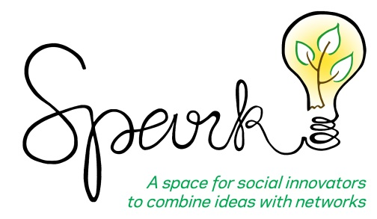
Spark Workshops provide social innovators with an opportunity to explore resources, connections, and potential solutions to help their social ventures. These workshops tap into the collective knowledge within Columbia University and the larger entrepreneurial and social impact community.

Spark is a platform for ventures to make valuable connections, as the audience is a self-selected group interested in the topic area. Ventures are also able to gather diverse ideas through group brainstorming to help them address specific questions or problems within the business or organization.

These workshops are free and open to all who are willing to bring their ideas, experience, and connections to help solve social and environmental challenges that social innovators aim to address.

Spark Workshop Application
Facilitator(s)
Name: Job Title:
Organization:
Email: Phone Number:
Have you attended any Spark Workshops in the past? If so, please list them:
Have you facilitated any workshops in the past? If so, at what forums, conferences, or venues? Please provide links to any videos of you speaking such events, if you have them:
Would you like to co-facilitate the workshop with any other individuals or organizations? If so, please include name, job title, and organization:

Please provide a short bio for each facilitator:

Venture
Please provide the following:
- Venture website, if applicable:
- Twitter, if applicable:
- Facebook, if applicable:
What is your venture called?

Is your venture a for-profit, nonprofit, or hybrid structure?

When did you launch your venture (if applicable)?

How large is the organization (revenue/employees)?

What is the social or environmental problem you are trying to solve, and how will your venture help to address this?

What customers/markets do you serve?

Please list media mentions or press articles featuring you or your venture, if applicable:

Spark Workshop
When would you like to host the workshop (ie. fall or spring semester, or a specific month)? If accepted to host a Spark Workshop, the Tamer Institute team will work with you to determine a specific date based on team bandwidth and room availability on campus.
What questions would you like to brainstorm around and crowdsource ideas from the audience in the Spark Workshop format? What challenges with your venture are you aiming to address?

What title would you use for the workshop? Please see here for past examples of workshop titles.

What materials would you need to facilitate this workshop (projector, post-it notes, flip charts, markers, etc.)?

Please outline a draft agenda and timeline breakdown for your proposed workshop. Please note that typically, Spark Workshops are held from 12:30-2pm or 6-8pm on Columbia University’s Manhattanville campus. A sample agenda is as follows:

6:00-6:10pm Attendee check-in and networking
6:10-6:30pm Overview of venture, your mission, and the work you have done to date
6:30-6:35pm Introduction of the questions would you like the audience to use for brainstorming. Audience to break into small groups
6:35-7:35pm Audience to brainstorm in small groups
7:35-8:00pm Small group report-out and full audience discussion

Please send your completed form to socialenterprise@gsb.columbia.edu.

